Day - 5 MongoDB Assignment

blog> use InsuranceDB

CREATION
InsuranceDB> db.createCollection("Customers")
{ ok: 1 }
InsuranceDB> db.createCollection("Agents")
{ ok: 1 }
InsuranceDB> db.createCollection("Policies")
{ ok: 1 }
InsuranceDB> db.createCollection("PolicyAssignments")
{ ok: 1 }
InsuranceDB> db.createCollection("Claims")
{ ok: 1 }
INSERTION OF DATA
db.Customers.insertMany([{ CustomerID: 1, FirstName: "Rahul", LastName: "Sharma", DateOfBirth: "1990-05-22", Phone: "9876543210", Email: "rahul@example.com" }, { CustomerID: 2, FirstName: "Sneha", LastName: "Reddy", DateOfBirth: "1995-11-12", Phone: "9123456780", Email: "sneha@example.com" }]);

db.Agents.insertMany([{ AgentID: 101, AgentName: "Ramesh", Phone: "9988776655", City: "Hyderabad" }, { AgentID: 102, AgentName: "Kiran", Phone: "8877665544", City: "Chennai" }]);

db.Policies.insertMany([{ PolicyID: 11, PolicyName: "Health Secure", PolicyType: "Health", PremiumAmount: 5000, DurationYears: 2 }, { PolicyID: 12, PolicyName: "Life Guard", PolicyType: "Life", PremiumAmount: 12000, DurationYears: 5 }]);

db.PolicyAssignments.insertMany([{ AssignmentID: 1001, CustomerID: 1, PolicyID: 11, AgentID: 101, StartDate: "2024-01-01", EndDate: "2026-01-01" }, { AssignmentID: 1002, CustomerID: 2, PolicyID: 12, AgentID: 102, StartDate: "2023-06-01", EndDate: "2028-06-01" }]);

db.Claims.insertMany([{ ClaimID: 501, AssignmentID: 1001, ClaimDate: "2024-03-10", ClaimAmount: 20000, ClaimStatus: "Approved" }, { ClaimID: 502, AssignmentID: 1002, ClaimDate: "2024-04-05", ClaimAmount: 15000, ClaimStatus: "Pending" }]);

InsuranceDB> db.customers.find()
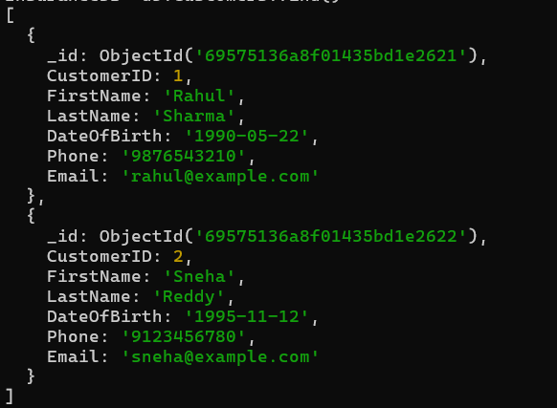
db.PolicyAssignments.find({CustomerID:1})
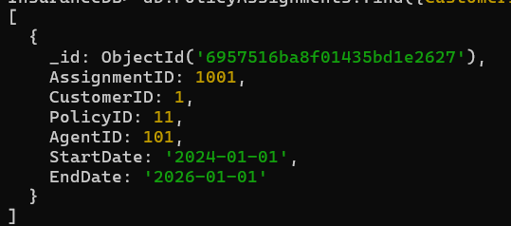
InsuranceDB> db.Customers.updateOne({CustomerId : 1},{ $set: {Phone:'7670836092'}})
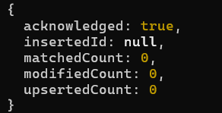
InsuranceDB> db.Customers.find()
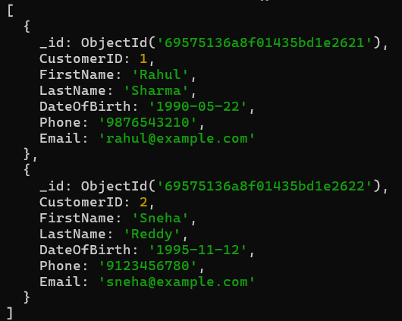
InsuranceDB> db.Customers.updateOne({CustomerID : 1},{ $set: {Phone:'7670836092'}})
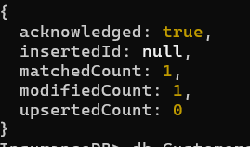
InsuranceDB> db.PolicyAssignments.countDocuments({AgentID:101})
InsuranceDB> db.Claims.find({ClaimAmount: {$gt: 10000}})
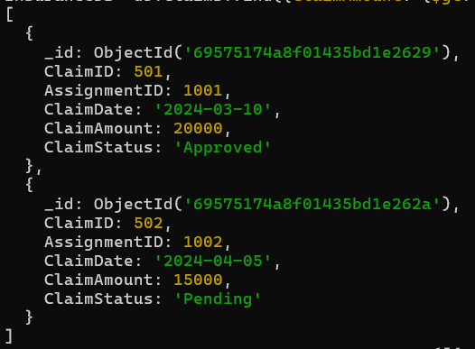
InsuranceDB> db.PolicyAssignments.aggregate([{ $lookup : {from:"Customers",localField: "CustomerID", foreignField: "CustomerID", as:"CustomerDetails"}}])
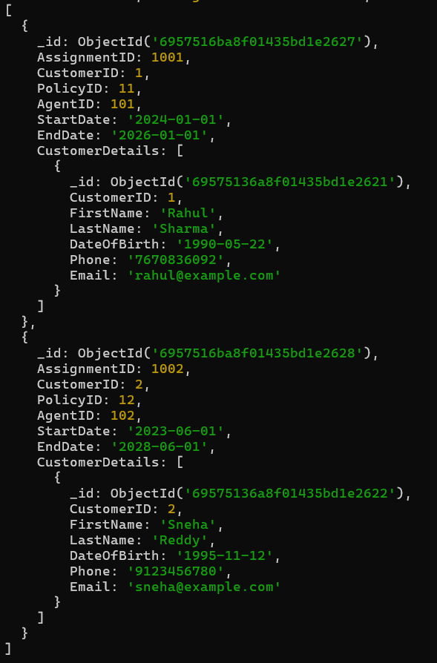
InsuranceDB> db.Policies.find({ PremiumAmount: { $gt: 6000 } })
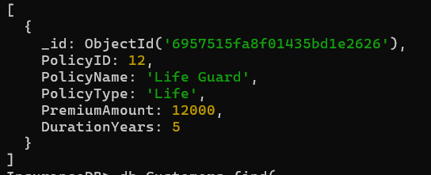
InsuranceDB> db.Customers.find(
... { CustomerID: 1 },
... { FirstName: 1, Email: 1, _id: 0 }
... )
InsuranceDB> db.Policies.find({ PolicyType: "Health", DurationYears: { $gte: 2 } })
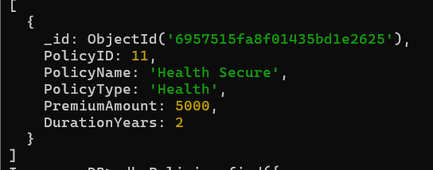
InsuranceDB> db.Policies.find({
... $or: [{ PolicyType: "Health" }, { PremiumAmount: { $lt: 10000 } }]
... })
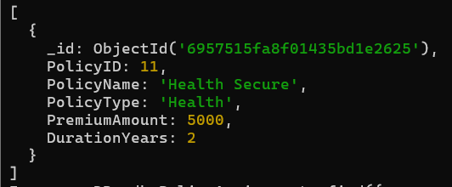
InsuranceDB> db.PolicyAssignments.find({
... CustomerID: { $in: [1, 2] }
... })
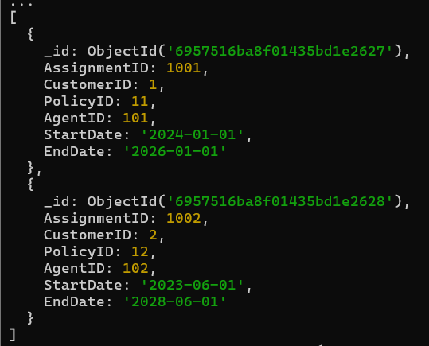
InsuranceDB> db.Customers.updateOne(
... { CustomerID: 1 },
... { $set: { Phone: "9000000000" } }
... )
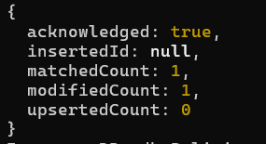
InsuranceDB> db.Customers.deleteOne({ CustomerID: 3 })
InsuranceDB> db.Claims.deleteMany({ ClaimStatus: "Pending" })
InsuranceDB> db.Policies.find().sort({ PremiumAmount: 1 })
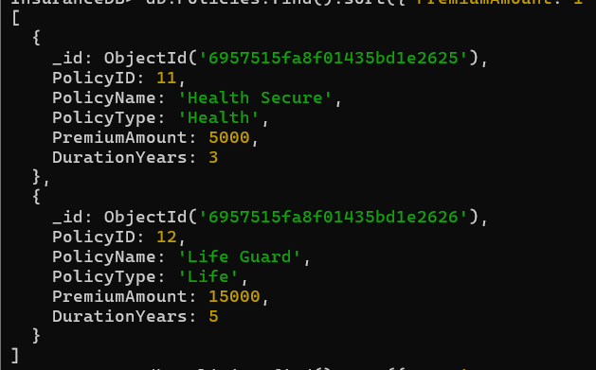

InsuranceDB> db.Policies.find().sort({ PremiumAmount: -1 })
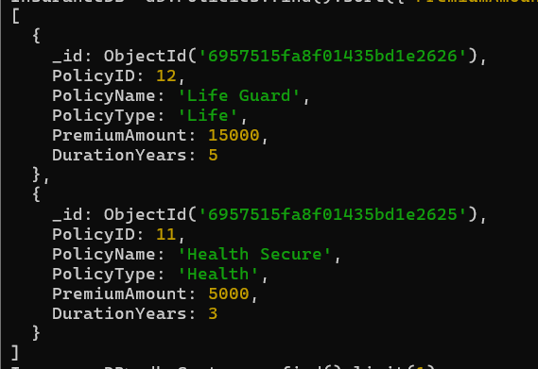

db.Claims.aggregate([{ $lookup: { from: "PolicyAssignments", localField: "AssignmentID", foreignField: "AssignmentID", as: "AssignmentDetails" } }, { $unwind: "$AssignmentDetails" }, { $group: { _id: "$AssignmentDetails.CustomerID", TotalClaims: { $sum: "$ClaimAmount" } } }])

db.PolicyDetails.aggregate([ { $sort: { PremiumAmount: -1 } }, { $limit: 1 } ])
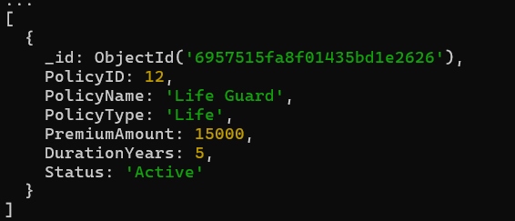
InsuranceDB> db.Customers.find({ CustomerID: { $type: "int" } })
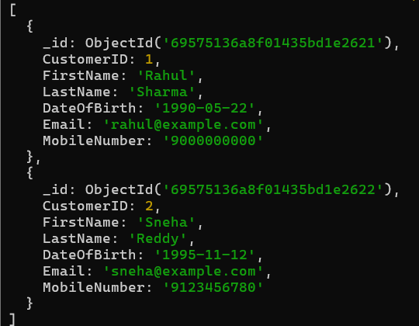
InsuranceDB> db.PolicyDetails.updateMany( {},{ $set: { Status: "Active" } })
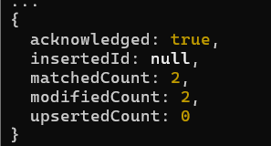
InsuranceDB> db.Customers.find({ Email: { $exists: true } })
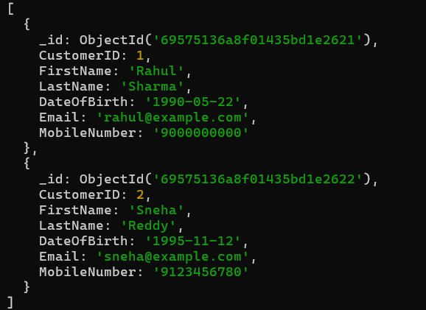
InsuranceDB> db.Policies.renameCollection("PolicyDetails")
InsuranceDB> db.PolicyDetails.distinct("PolicyType")
InsuranceDB> db.Customers.updateMany({}, { $rename: { "Phone":
"MobileNumber" } } )
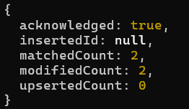

InsuranceDB> db.Customers.find({ FirstName: { $regex: /^S/ } })
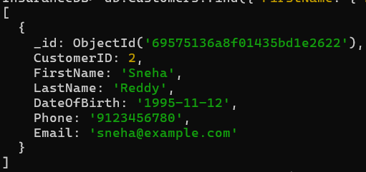
InsuranceDB> db.Customers.countDocuments()
2
InsuranceDB> db.Claims.aggregate([{ $match: { ClaimStatus: "Approved" } },
{ $group: { _id: "$AssignmentID", TotalAmount: { $sum: "$ClaimAmount" } } }
])

